Pre-req Unix Commands

This section gives the following table which has list of Linux commands.

* Command: pwd
* How to use: pwd



* Explanation: Present Working Directory

------------------------------------------------------------------------------------------------------------------------

* Command: ls
* How to use: ls /directory path
* ex: ls /home/cloudera

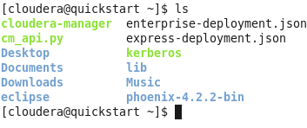

* Explanation: List file

--------------------------------------------------------------------------------------------------------------------------------------------

* Command: ls -ll
* How to use: ls –ll
* ex:ls -ll

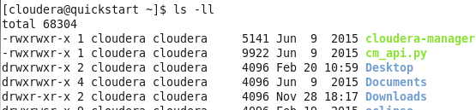

* Explanation: Long list of files and directory ‘d’ Indicates Directory, ‘-‘ Indicates File

------------------------------------------------------------------------------------------------------------------------------------------------

* Command: ls -al
* How to use:ls –al
* ex:ls –al

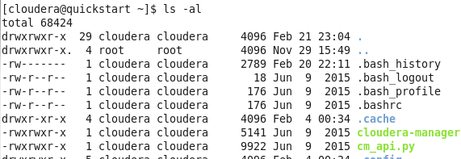

* Explanation: Listing all hidden filesOr Directory

-------------------------------------------------------------------------------------------------------------------------------------------------

* Command: mkdir
* How to use: mkdir

ex: mkdir Work

* eg: 1)mkdir dir1
* 2)mkdir dir1 dir2 dir3

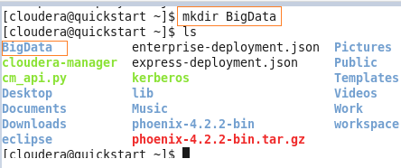

Explanation: Create directory For Creating Multiple Directories

-------------------------------------------------------------------------------------------------------------------------------------------------

* Command: rm -r
* How to use: rm –r /directory_pathex: rm -r /home/cloudera/directory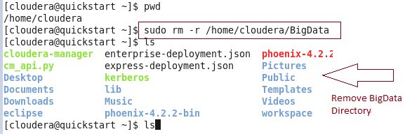
* Explanation: Remove directory or file

------------------------------------------------------------------------------------------------------------------------------------------------

* Command: cd
* How to use: cd directoryname
* ex: cd BigData

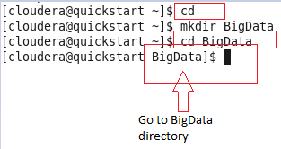

* Explanation: To change the directory

------------------------------------------------------------------------------------------------------------------------------------------------

* Command: cd ..
* How to use: cd ..
* ex:cd ..

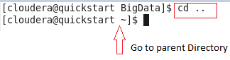

* Explanation: To change the directory

-------------------------------------------------------------------------------------------------------------------------------------------------

* Command: cd ~
* How to use: cd ~
* Explained:go home directory

--------------------------------------------------------------------------------------------------------------------------------------------

* Command: cp
* How to use:cp src_file_path /destination_directory_path
* ex: cp file1 dir1
* cp dir1/* dir2
* cp text /home/cloudera/Work

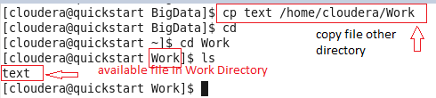

* Explanation:Copy filesAll the files in dir1 are copied into dir2. dir2 must already

-------------------------------------------------------------------------------------------------------------------------------------------------

* Command: mv
* How to use:mv src _file_path/destination_dir._path
* ex: mv myfile.txt /newdirectorymv current_filename new_filename
* eg:mv text /home/cloudera/BigData/text.text

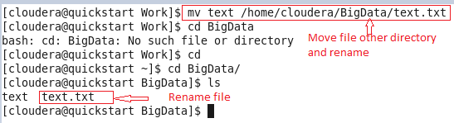

* Explanation:Renames a file or moves it from one directory to another directory

--------------------------------------------------------------------------------------------------------------------------------------------

* Command: rm
* How to use:rm file_pathex: rm file1rm -r dir1sudo rm text.txt

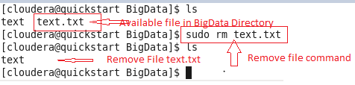

* Explanation:Delete file1 silently Delete dir1 and its contents

--------------------------------------------------------------------------------------------------------------------------------------------

* command:cat
* How to use:cat /file_pathex: cat /home/cloudera/file_name

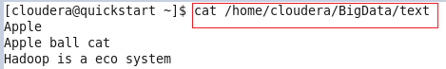

* Explanation:View files

-------------------------------------------------------------------------------------------------------------------------------------------------

* Command:gedit
* How to use:gedit /file_path
* eg:gedit work.txt

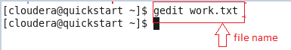

* Explanation:Text editor

-------------------------------------------------------------------------------------------------------------------------------------------------

* Command:stat
* How to use:stat /file_path
* ex: /home/cloudera/Work/student

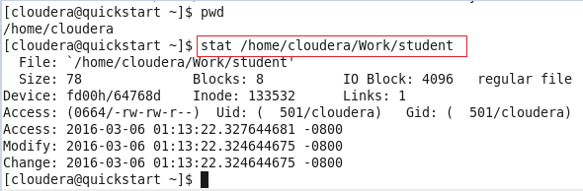

* Explanation:Display file attributes(properties)

-------------------------------------------------------------------------------------------------------------------------------------------------

* Command:wc
* Ho to use:wc /file_path
* ex: wc /home/cloudera/Work/student

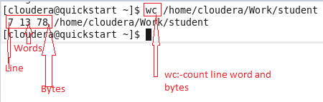

* Explanation:Count lines/words/bytes

-------------------------------------------------------------------------------------------------------------------------------------------------

* Command:chown
* How to use:chown user_name file_path
* ex: chown cloudera /home/cloudera/Work/student.txt

chown [owner][:[group]] file...

* Explanation:Change file owner Change the owner and group owner of a file or directory

-------------------------------------------------------------------------------------------------------------------------------------------------

* Command:chgrp
* How to use:chgrp group_name /file_path
* ex: chgrp admin /home/cloudera/Work/student.txt
* Explanation:Change file group

-------------------------------------------------------------------------------------------------------------------------------------------------

* Command:chmod
* How to use:chmod permission /file_path file_name
* ex:1) sudo chmod 775 /home/cloudera/Work/student
* 2)sudo chmod –R 775 /home/cloudera/Work/
* Explanation:To change permission of a file Use option -R to change the permission recursively

-------------------------------------------------------------------------------------------------------------------------------------------------

* Command:ifconfig
* How to use:ifconfig
* ex:ifconfig

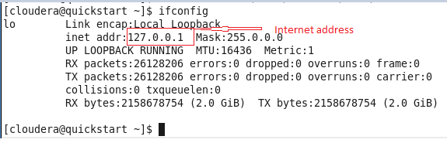

* Explanation:Set/display networkinformation/ Ip address

-------------------------------------------------------------------------------------------------------------------------------------------------

* Command:ps
* How to use:ps

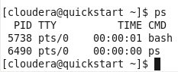

* Explanation:To view processes

-------------------------------------------------------------------------------------------------------------------------------------------------

* Command:passwd
* How to use:Passwd

(current) UNIX password:

New password:

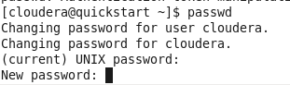

* Explanation: Change the password

-------------------------------------------------------------------------------------------------------------------------------------------------

* Command:chattr
* How to use:sudo chattr +i/-i /file_path
* ex:sudo chattr +I /home/cloudera/Work/studen



* Explanation:Change advanced file attributes

-------------------------------------------------------------------------------------------------------------------------------------------------

* Command:tail
* How to use:tail filename
* ex: tail /home/user/cloudera/Work/student

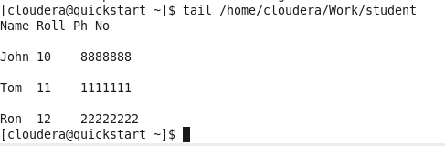

* Explanation:Prints last few lines in a file

-------------------------------------------------------------------------------------------------------------------------------------------------

* Command:grep
* How to use:grep ‘word’ filename
* ex:grep student
* Explanation:Search files for regular expression

-------------------------------------------------------------------------------------------------------------------------------------------------

* Command:sed
* How to use:Sed 's/unix/linux/' filename
* ex: sed 's/unix/linux/' /home/cloudera/Work/student
* sed 's/unix/linux/g' /home/cloudera/Work/student

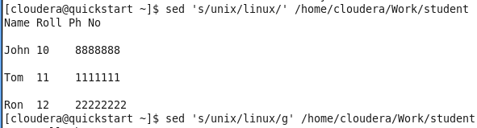

* Explanation:Replacing or substituting string(the "s" specifies the substitution operation) By default, the sed command replaces the first occurrence of the pattern in each line

----------------------------------------------------------------------------------------------------------------------------------------------

* Command:head
* How to use:head filename
* ex head /home/cloudera/Work/student

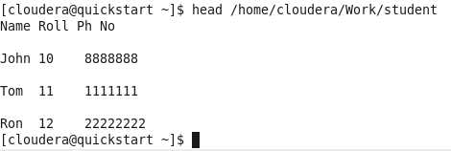

* Explanation:Display first few lines of a file

-------------------------------------------------------------------------------------------------------------------------------------------------

* Command:file
* How to use:file filename
* ex file /home/cloudera/student.txt

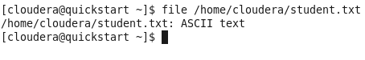

* Explanation:Determine file type

-------------------------------------------------------------------------------------------------------------------------------------------------

* Command:man
* How to use:man filename
* ex: man /home/cloudera/student.txt



* Explanation:Displays manual pages online

-------------------------------------------------------------------------------------------------------------------------------------------------

* Command:sort
* How to use:Sort filename
* ex:sort /home/cloudera/student.txt

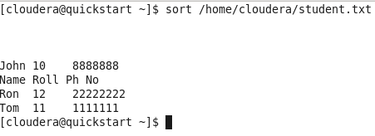

* Explanation:Sort file data

-------------------------------------------------------------------------------------------------------------------------------------------------

**Advance Unix Command:**

* Command: dig
* How to use: dig bigdatatrunk.com

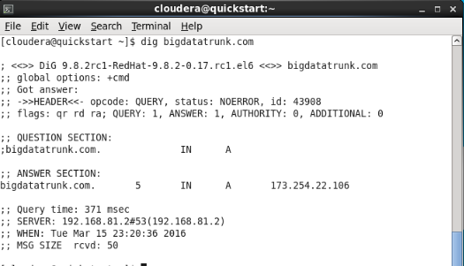

* Explanation: dig (domain information groper) is a network administration command-line tool for querying Domain Name System (DNS) name servers. dig is useful for network troubleshooting and for educational purposes.

------------------------------------------------------------------------------------------------------------------------------------------------

* Command: kill
* How to use: kill -9 pid

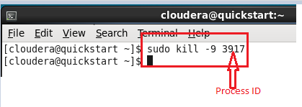

* Explanation: It will allow you to terminate a process.Here 'pid' is the Process ID (PID)

-------------------------------------------------------------------------------------------------------------------------------------------------

* Command: history
* How to use: history

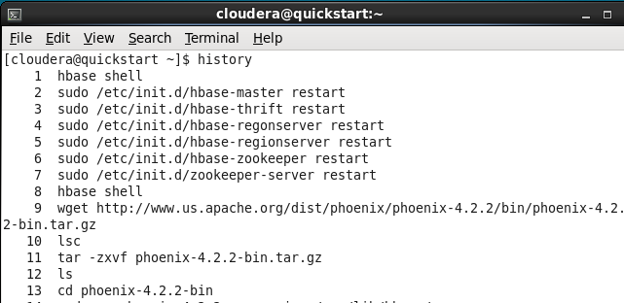

* Explanation: check history of command or to get info about command executed by user.

--------------------------------------------------------------------------------------------------------------------------------------------------

* Command: whatis
* How to use:whatis ls

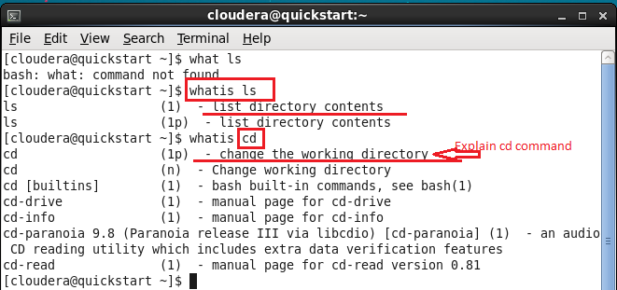

* Explanation:Whatis command is helpful to get brief information about Linux commands or functions. Whatis command displays man page single line description for command that matches string passed as a command line argument to whatis command.

------------------------------------------------------------------------------------------------------------------------------------------------

* Command: wget
* How to use:wget http://javadl.oracle.com/webapps/download/AutoDL?bundledID=116037

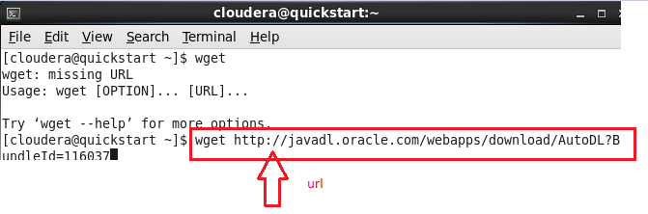

* Explanation:wget is a Linux/UNIX command line file downloader.Wget is a free utility for non-interactive download of files from the Web.

------------------------------------------------------------------------------------------------------------------------------------------------

* Command: netstat
* How to use:netstat -i

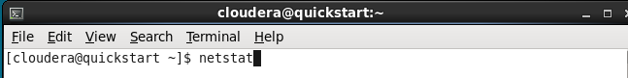

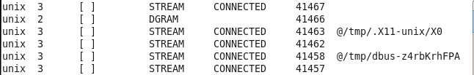

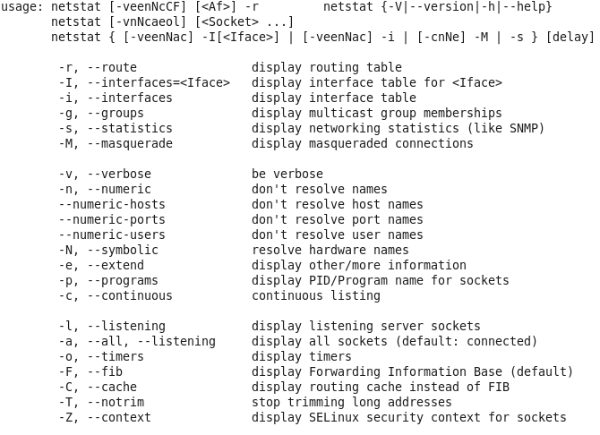

* Explanation:Netstat is a command line utility that can be used to list out all the network (socket) connections on a system. It lists out all the tcp, udp socket connections and the unix socket connections.

--------------------------------------------------------------------------------------------------------------------------------------------

* Command: nslookup
* How to use:nslooku

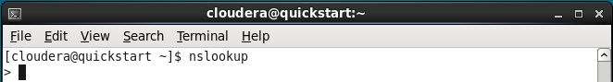

* Explanation:nslookup is a network administration tool for querying the Domain Name System (DNS) to obtain domain name or IP address mapping or any other specific DNS record.

------------------------------------------------------------------------------------------------------------------------------------------------

* Command: lsof
* How to use:lsof +d /var/log

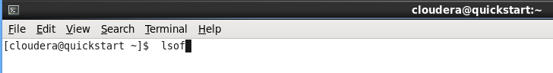

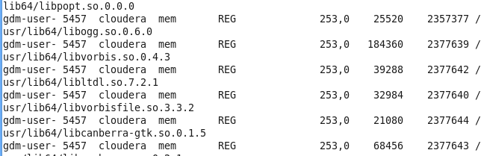

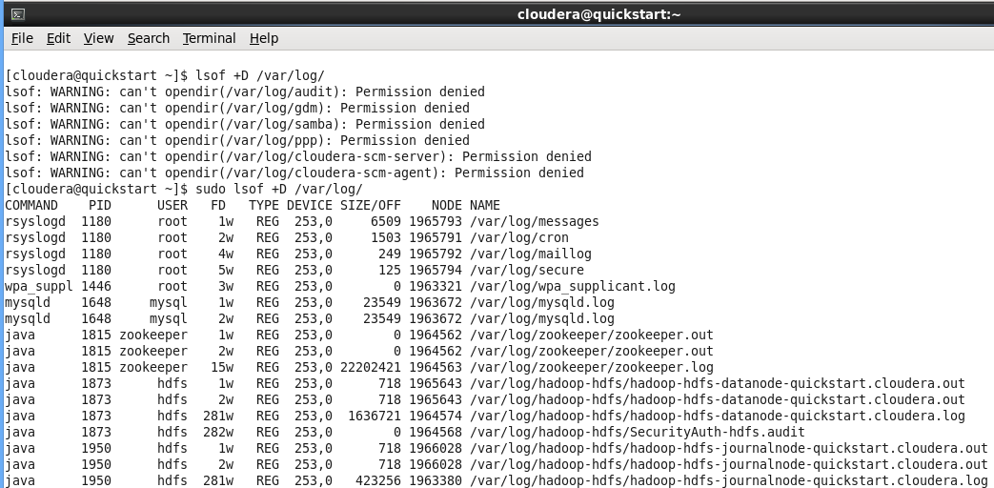

* Explanation:It is easy to remember lsof command if you think of it as “ls + of”, where ls stands for list, and of stands for open files.

----------------------------------------------------------------------------------------------------------------------------------------------

* Command: free
* How to use:free

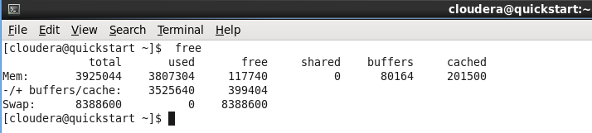

* Explanation:free is a command which can give us valuable information on available RAM in Linux machine. But many new Linux users and admins misinterpret its output. In this post we will walk through its output format and show you actual free RAM.

-----------------------------------------------------------------------------------------------------------------------------------------------

* Command: vi/nano
* How to use:vi BigData

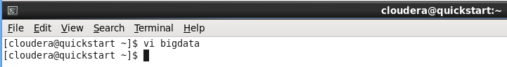

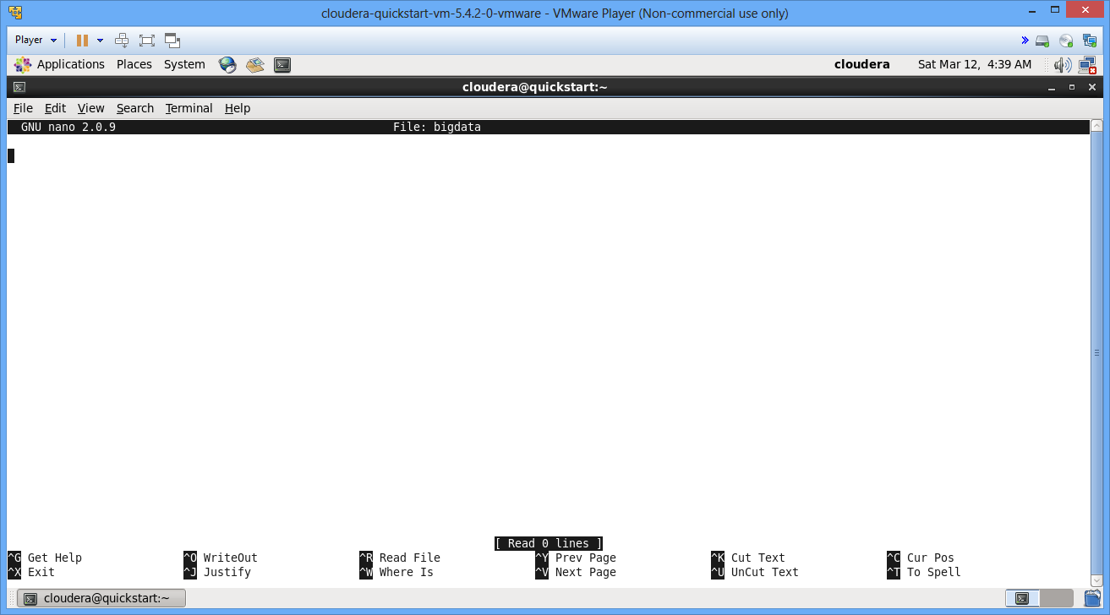

* Explanation:one of the best ways is using screen-oriented text editor vi. This editor enable you to edit lines in context with other lines in the file.

----------------------------------------------------------------------------------------------------------------------------------------------

* Command: who
* How to use:who am i
* who -ah

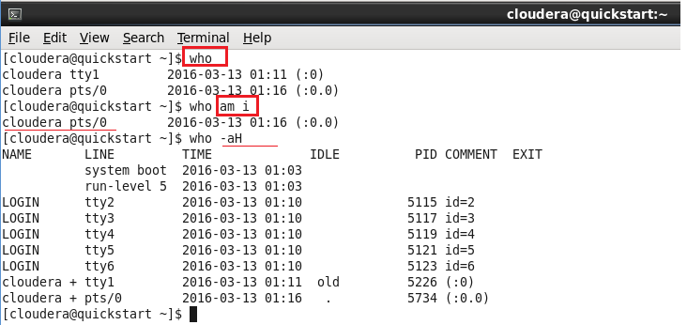

* Explanation:The who command prints information about all users who are currently logged in.

------------------------------------------------------------------------------------------------------------------------------------------------

* Command: uptime
* How to use:uptime

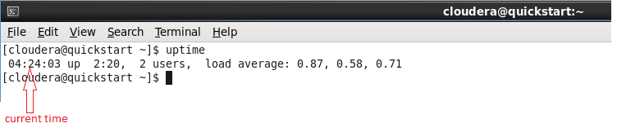

* Explanation:uptime gives a one-line display of the following information:
* The current time
* how long the system has been running
* how many users are currently logged on
* the system[load](http://www.computerhope.com/jargon/l/load.htm) averages for the past 1, 5, and 15 minutes.

-----------------------------------------------------------------------------------------------------------------------------------------------

* Command: bc
* How to use:bc

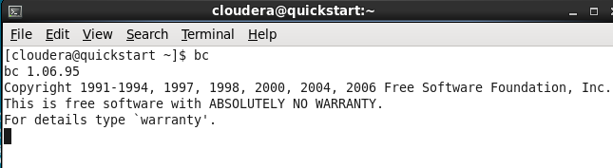

* Explanation:Unix or linux operating system provides the bc command andexpr command for doing arithmetic calculations. You can use these commands in bash or shell script also for evaluating arithmetic expressions.

-----------------------------------------------------------------------------------------------------------------------------------------------

* Command: top
* How to use:top

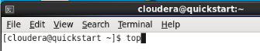

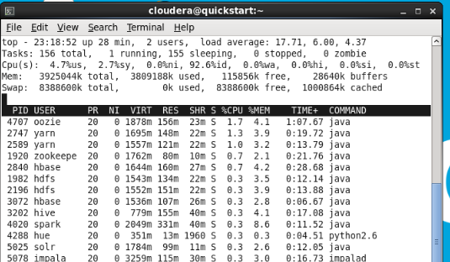

* Explanation:The top command provides a dynamic real-time view of a running system. It can display system summary information, as well as a list of[processes](http://www.computerhope.com/jargon/p/process.htm) or threads currently being managed by the[kernel](http://www.computerhope.com/jargon/k/kernel.htm).

-------------------------------------------------------------------------------------------------------------------------------------------

* Command: w
* How to use:w

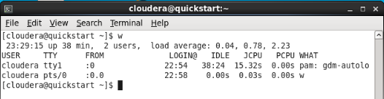

* Explanation:w displays information about the users currently on the machine, and their processes. The header shows, in this order, the current time, how long the system has been running, how many users are currently logged on, and the system load averages for the past 1, 5, and 15 minutes.

--------------------------------------------------------------------------------------------------------------------------------------------

* Command: join
* How to use:join

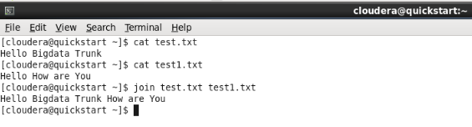

* Explanation:Join command is one of the text processing utility in Unix/Linux. Join command is used to combine two files based on a matching fields in the files.

--------------------------------------------------------------------------------------------------------------------------------------------

* Command:cal
* How to use:cal

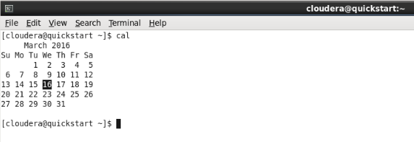

* Explanation:A. date displays the Linux or UNIX system current date and time. The cal command displays a simple calendar

-----------------------------------------------------------------------------------------------------------------------------------------

* Command:df
* How to use:df

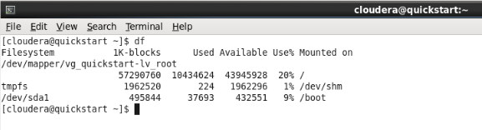

* Explanation:The 'df' command stand for “disk filesystem“, it is used to get full summary of available and used disk space usage of file system on Linux system.
* Command:du
* How to use:du

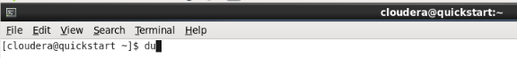

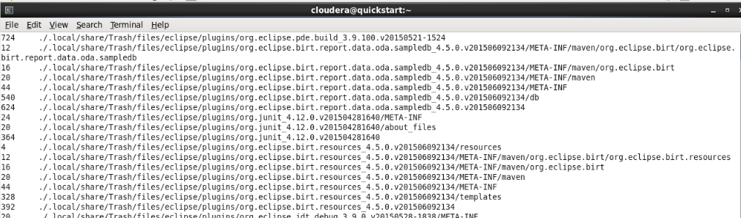

* Explanation:The Linux “du” (Disk Usage) is a standard Unix/Linux command, used to check the information of disk usage of files and directories on a machine.